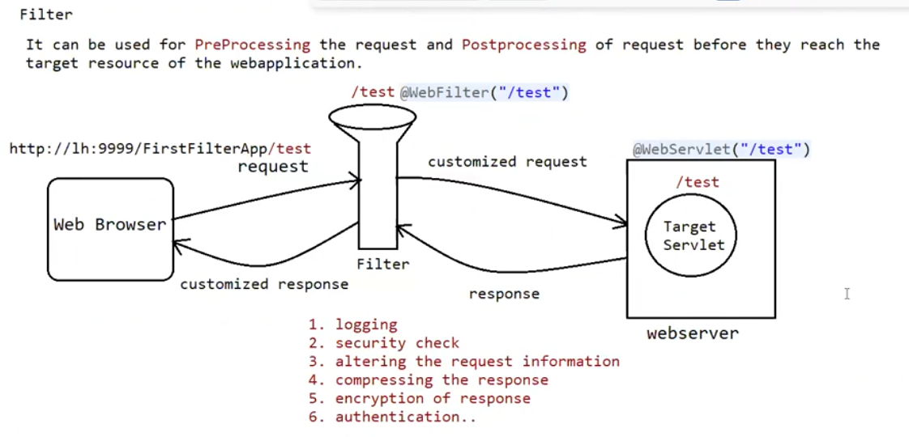

Eg: FirstFilterApp

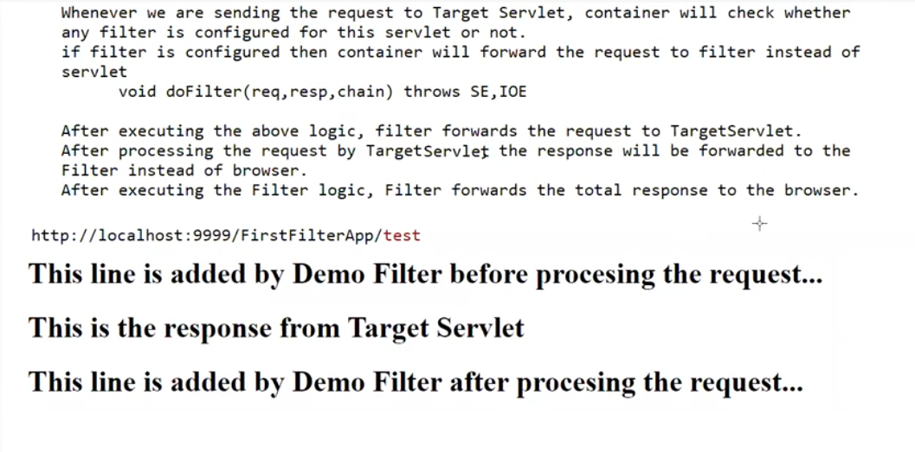

Filter chaining :

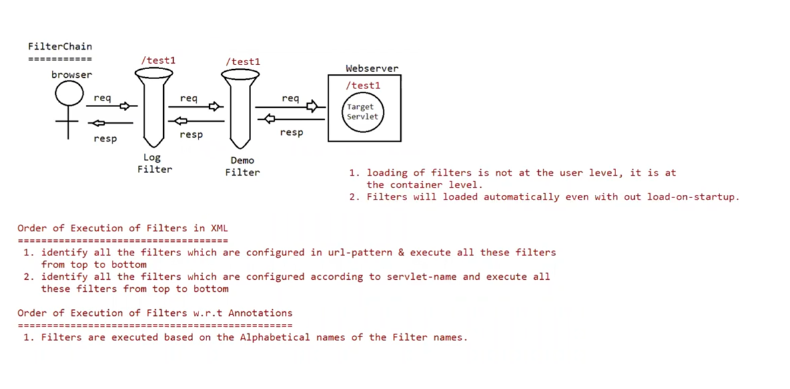

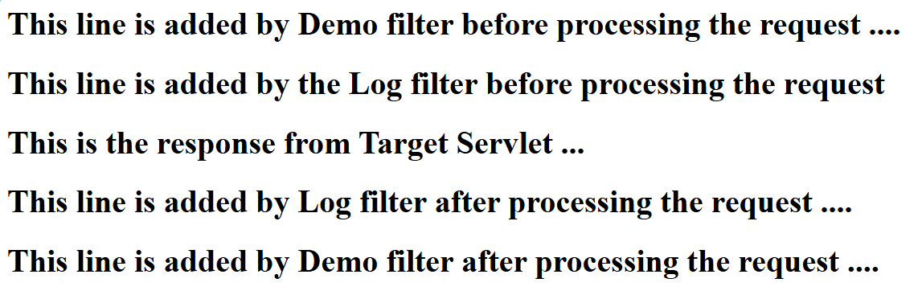

Eg: FilterChainingApp

Eg: CustomizedRequestApp

// work on customized response also.

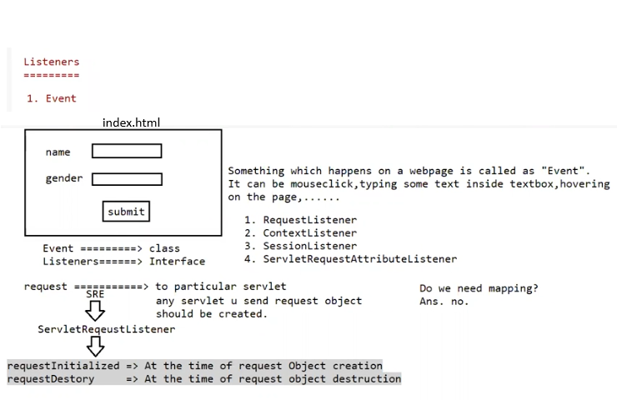

Eg: ListenerApp